**Support Your Immune System With These 5 Yoga Poses for Immunity:**

Let’s explore five yoga poses for immunity to help your body help itself when the cold and flu season hits hard.

**1. Sitting and Breathing (Sukhasana and Pranayama)**



When it comes to boosting your immunity, sometimes the simplest approach can be the most effective.

*How It Helps:*  
Sukhasana is the traditional pose for meditation. It allows for optimal breathing and movement of [“prana” (life force energy)](https://www.yogiapproved.com/health-wellness/demystifying-prana-enhance-life-force-energy/)throughout the body.

Allowing yourself to relax and breathe deeply can help reduce stress hormones, heart rate, and nervous system distress (which all supports strong immunity). Breathing through a U-shaped tongue for a minimum of three minutes is believed to [help reduce a fever](https://www.yogajournal.com/lifestyle/support-your-immune-system).

*Let’s Try It:*

* Find a comfortable seat with your legs either crossed or kneeling. (If you’re in a chair, make sure you have a firm connection to the floor under your feet)
* Stack your shoulders over your hips, head over your shoulders, and slightly tuck the chin so the crown of the head reaches tall
* Inhale length up the entire spine, exhale and feel rooted in your seat
* Stay for as long as it feels good but at least 10 deep breaths

**2. Half Lord of the Fishes (Ardha Matsyendrasana)**



Spinal twists decompress and nourish the spine, but they can also help a lot with our body’s internal functions, including our immune system.

*How It Helps:*  
The theory behind twists helping our immunity is that improper digestion causes toxins to build-up. These nasty toxins send the body out of whack and have the potential to create infection or inflammation. Yoga poses that gently compress, twist, or stimulate the stomach can help with digestive issues.

*Let’s Try It:*

* Sitting with your legs straight out in front of you, plant your right foot on the outside of your left leg so the sole of your right foot is on the mat
* Keep the extended left foot flexed. Option to cross the left foot under the right leg and near the right hip)
* On an inhale, plant your right palm directly behind your low back and bring your left elbow to the outside of your right knee
* Inhale to lift and lengthen your spine, exhale to twist and shift the gaze over the right shoulder
* Stay for 5 breaths on each side

**3. Supported Fish Pose (Matsyasana Variation)**

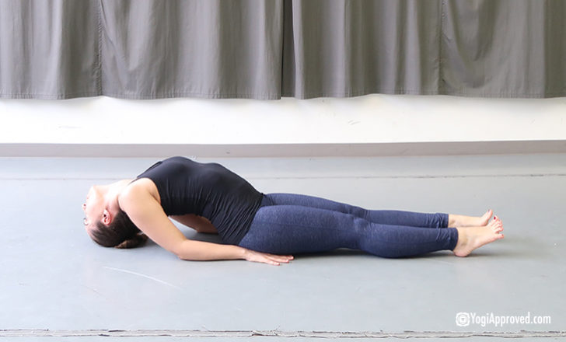

Arguably one of the most feel-good restorative variations, Supported Fish makes an already yummy pose feel even better, and is also a great yoga pose for immunity.

*How It Helps:*  
When you’re really feeling beat, this yoga pose boosts your energy levels when you’ve been depleted. Supported Fish Pose also targets the lungs, so it can help open up and relieve congestion.

*Let’s Try It:*

* If you have one, grab your [yoga bolster](https://amzn.to/335lIas) and/or [yoga blocks](https://amzn.to/33ar04C) (if you don’t have these, a rolled up blanket works great!)
* If you have two yoga blocks, place one on the mat beneath your heart and one beneath the back of your head. If you have a bolster, place it on top of the blocks or in their place
* If you’re using a blanket, roll it up and position it so the blanket ends at the middle of your back and the top of the blanket roll supports your head
* Relax your chest and shoulders and let your arms open wide, palms facing up
* Legs can either be out straight or bent with feet as wide as your mat and the knees touching in the center
* Stay in this pose for 1-5 minutes

**4. Forward Fold (Uttanasana)**

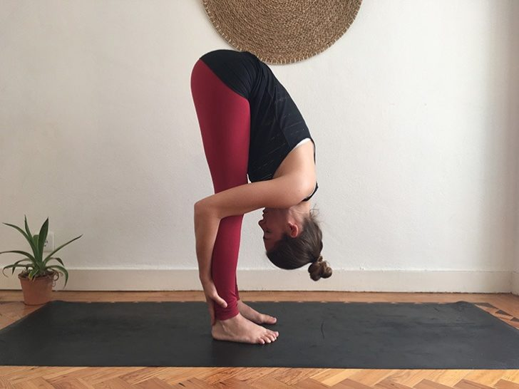

Inversions bring a wealth of benefits to mind and body, and inversions include way more yoga poses than just a handstand! Forward Fold is the perfect gentle inversion to boost immunity.

*How It Helps:*  
Inverted postures and forward bends bring prana and blood flow to the sinuses, which can help ease congestion. Sinuses and our mucus membranes are our body’s first line of defense against infection, so keeping them healthy can [boost our immune system function](https://www.hopkinsmedicine.org/news/media/releases/immune_system_kick_started_in_moist_nasal_lining_in_sinusitis_asthma_and_colds).

However, depending on the level of congestion you are experiencing, this might be uncomfortable or agitating for the sinuses. As with any time you practice yoga, it’s important to check in with your body and back off or skip a pose when needed.

*Let’s Try It:*

* From standing, bring your feet hip-distance apart
* Slowly hinge at the hips and keep a bend in your knees as you come into a gentle forward fold
* Option to hang ragdoll or allow your hands to rest on the floor, [yoga blocks](https://amzn.to/33ar04C) or on your ankles, calves or thighs
* Stay here for 5-10 breaths or as long as feels good
* When you come out of this pose, roll yourself slowly to standing to prevent any dizziness

**5. Legs Up the Wall (Viparita Karani)**

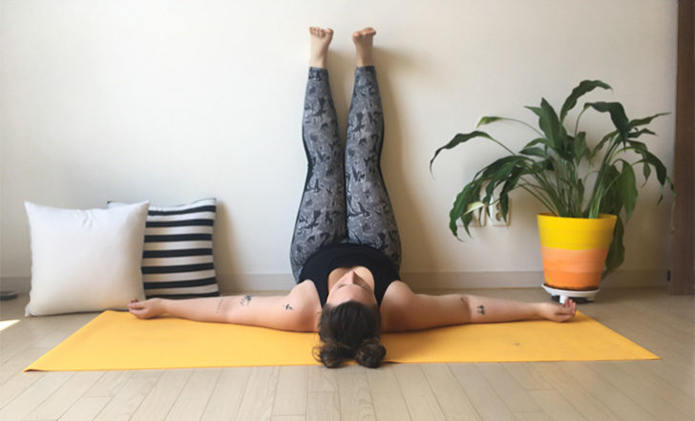

The ultimate stress-busting yoga pose, Legs Up the Wall should also be a staple when you practice yoga for immunity.

*How It Helps:*  
Legs Up the Wall is one of the most relaxing yoga poses for your whole body. It allows lymph drainage, blood circulation to even out, releases pressure from your back, and helps you feel grounded, so in turn your nervous system can completely relax and reset.

For optimal immunity, we need our nervous system to be fortified and functioning properly.

*Let’s Try It:*

* Sit about 3 inches away from an empty wall
* Lie onto your back and swing your legs up onto the wall, so the back of your thighs rest against the wall (you can scooch a little closer if needed)
* Allow your entire spine to rest heavy on the mat or floor beneath you, and relax your arms by your sides or on your stomach
* Pro Tip: It might feel good to add some weight on top of your feet to feel even more grounded (a book, sandbag, or pillow works great)
* Stay here for 1-10 minutes

**Help Your Immune System Help You By Practicing These Yoga Poses for Immunity**

Yoga can be one of our greatest tools in supporting a strong immune system and keeping all our body’s systems working optimally to prevent getting sick (or help us recover quicker).

By cultivating balance in our body and its systems, we can support, nourish, strengthen and build our health, immunity, energy and overall quality of life. These five simple yoga poses for immunity are a great way to start!

What are your favorite yoga poses to do when you’re feeling a little under the weather? Please share in the comments below – we love hearing from you!

*This article and all included information is not intended as medical advice and does not treat or diagnose. Please consult with your healthcare provider for any health-related questions or concerns.*